1. Open MATLAB. This example was written with MATLAB 2020a and STK 12.2
2. Under the ‘Home’ tab, click Simulink (), which will open the Start Page
3. Create a new ‘Blank Model’
   1. This will open a new window called ‘untitled’
4. Open the Library Browser ()
   1. Look under Simulink for ‘User-Defined Functions’
   2. Click and drag the ‘Level-2 MATLAB S-Function’ block into your ‘untitled’ model
      1. This allows you to put a MATLAB script into the Simulink block and tell the model what to do with the inputs and outputs

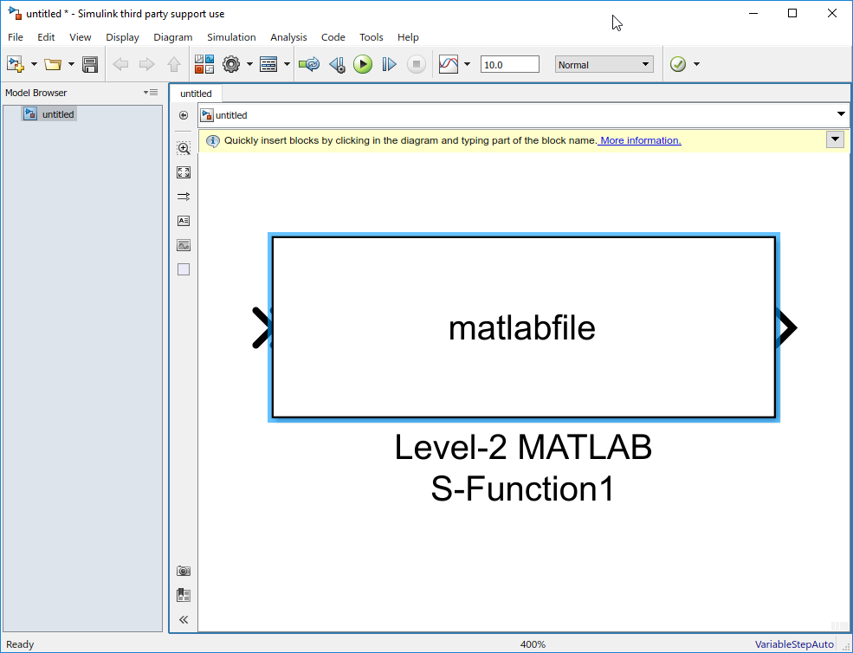

* 1. Choose Save > Save As > ‘SimpleSTK_Simulink.slx’ in its own folder
  2. Double-click the block and it will open another window to define the parameters
     1. MATLAB provides a helpful template to give you an idea of the setup
  3. Click the ‘Help’ button, which will open up the help documentation

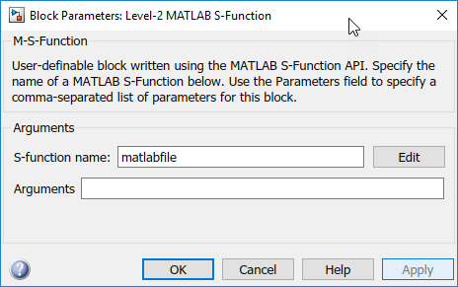

* 1. Under Description, click the ‘Write Level-2 MATLAB S-Function’ link
  2. Use the ‘msfuntml_basic.m’ template by clicking the link under Level-2 MATLAB S-Function Template
     1. This will open up the ‘msfuntml_basic.m’ file in MATLAB
  3. Copy the template and paste it into a new *.m file
  4. Save the file as ‘SimpleSTK_S_block.m’ in a separate folder which will contain your Simulink model
  5. Rename the function with the same name ‘SimpleSTK_S_block’



1. In the ‘SimpleSTK_S_block.m’ file, look for the Outputs(block) function
   1. Every time the Simulink model is called, the parameters in this function are refreshed
   2. We want to connect Simulink to STK using the actxserver we are familiar with in MATLAB, but we do not want this connection refreshed every time the model is run
      1. We will create an init function to be called once initially to establish the connection and store the COM handle for our S-block to use
   3. Return back to the ‘SimpleSTK_Simulink’ Simulink model and in the Block Parameters, set your ‘SimpleSTK_S_block’ as the S-function name and click OK

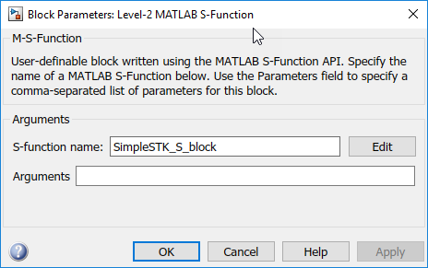

1. Right-click on the ‘Level-2 MATLAB S-Function’ block and choose Properties
   1. Click the Callbacks tab
   2. Look for the InitFcn
      1. This is where we will initialize connection to STK, create or modify any objects in the scenario, and point references to any variables we want to update
   3. Add the following code in the InitFcn callback:

close all

clear all

clc

% Create a new instance of STK12

uiapp = actxserver('STK12.Application');

uiapp.visible = 1;

% Get the object model root for STK12, IAgStkObjectRoot

root = uiapp.Personality2;

% Create a new scenario named SimpleSTK

root.NewScenario('SimpleSTK');

% Create a satellite named TestSat, propagate with default properties

satObj = root.CurrentScenario.Children.New('eSatellite', 'TestSat');

satObj.Propagator.Propagate;

% Store the uiapp and root objects in the UserData property for the block

stkParams = cell(3,1);

stkParams{1} = uiapp;

stkParams{2} = root;

stkParams{3} = satObj;

set_param(gcb, 'UserData', stkParams);

* + 1. This will connect to STK 12, grab a handle on the Personality2 root, create a new scenario called ‘SimpleSTK’, create a new default satellite called ‘TestSat’, and store the handle objects into the ‘UserData’ variable, which we will use in the S-block function

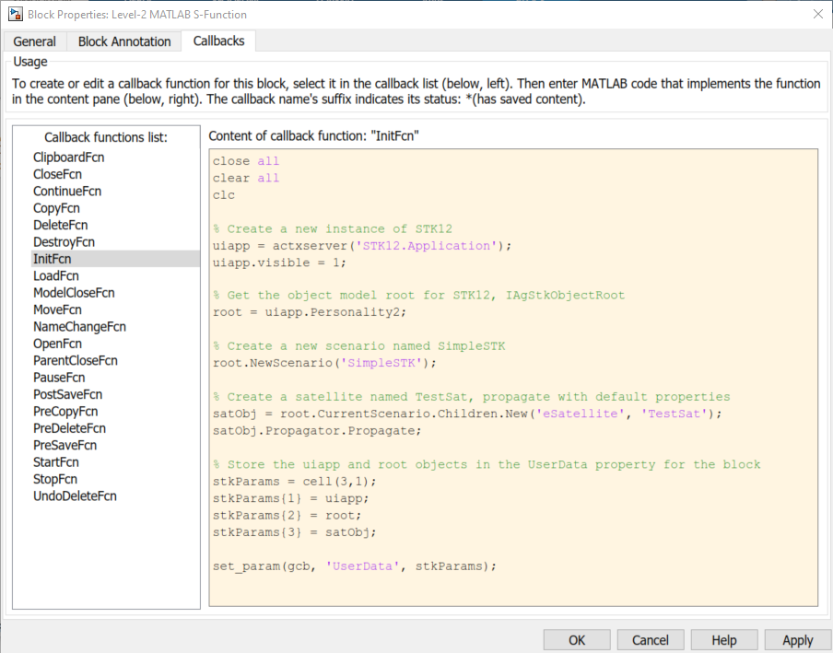

* 1. Click OK

1. Return to the ‘SimpleSTK_S_block.m’ file and go to the function Outputs(block) section
   1. Remove the block.OutputPort(1).Data line and add the following code:

% Get the User data

stkParams = get_param(block.BlockHandle, 'UserData');

% Get the object model root and the satellite from the cell array

root = stkParams{2};

satObj = stkParams{3};

% Set STK's time to match Simulink's time

root.CurrentTime = block.CurrentTime;

% Set the satellite's label to match the simulink time

satObj.Graphics.UseInstNameLabel = 0;

satObj.Graphics.LabelName = num2str(block.CurrentTime);

* + 1. This will grab the UserData variable containing the STK parameters we set in the initFcn (root and satObj), set the time of the STK scenario to the Simulink block time so Simulink is driving the STK time, change the satellite’s label to match the current time
  1. Save the SimpleSTK_S_block.m’ file and return to the Simulink model

1. Open the Model Settings () on the Modeling tab of the ‘SimpleSTK_Simulink’ Simulink model
   1. Under Solver, increase the Stop time to a large number, 10000000
   2. Change the Type to a Fixed-step so that it runs a bit slower to properly visualize it
      1. Expand the ‘Solver details’ and set the ‘Fixed-step size’ to 1

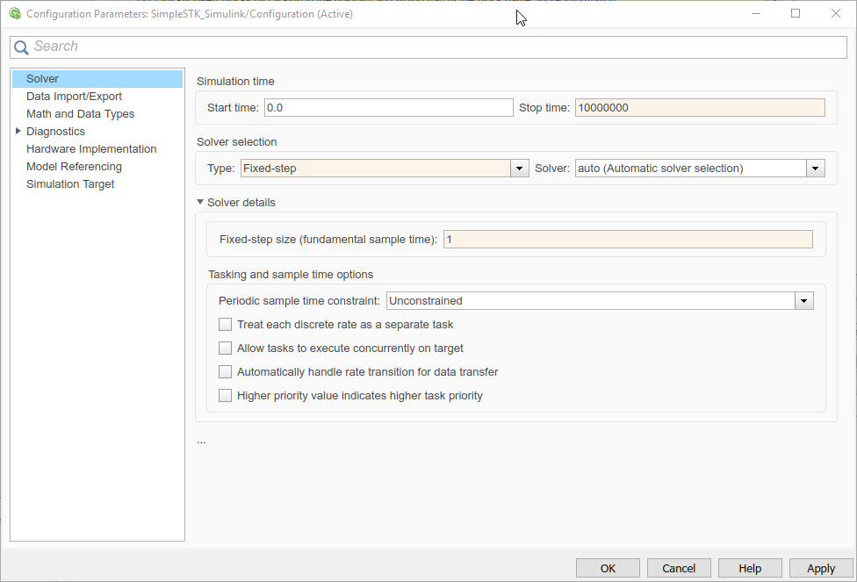

* 1. Click OK

1. Click the Run button ()
   1. This will call the initFcn and then watch as the satellite propagates and plays through time with the label updating as time passes
   2. Make sure the S-function file is in the MATLAB path
2. Click the Pause () or Stop () buttons at any time during the simulation
3. This simple tutorial shows the very basics of connecting Simulink to an STK scenario